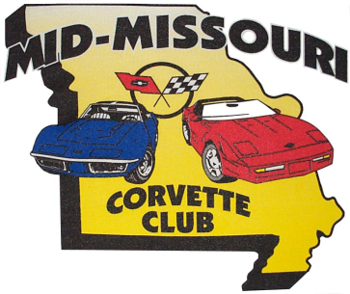
Mid-Missouri Corvette Club 25th Annual Corvette Cup

April 6, 2019

New Location* Hilton Garden Inn * New Location

3300 Vandiver Drive
Columbia, Missouri
573-814-5464
Pre-registration $50 Registration after March 23, $60

Pre-registration includes Saturday Awards Banquet for One,

Special Pre-Registration Gift & Event T-Shirt

Mail registration to:

Tommy Mallory, 13101 S Joy Rd, Ashland, MO. 65010

OR, TO REGISTER AND PAY ONLINE:
click here to register online

Make checks payable to Mid-Missouri Corvette Club or click on the link to pay by Debit and Credit Card

Name: __________________________________________
Address: ________________________________________
City: _______________________State: ___________Zip: _________

Spouse/Guest Name: ______________2nd meal ticket $15_____________
Event T-Shirt Size:________ Additional T-Shirts: $15 Size:____________
Phone_________________

Vehicle License: _________Year, Color, Coupe/Conv/GS: ____________

Club Affiliation____________________Insurance Carrier______________

Release & Waiver; Please be aware MMCC requires event participants and their guest (if any) to sign a release and Waiver at the event registration indemnifying MMCC and the host venue of all losses, injuries, and/or damages that may result as a participant in the event.

Signature of entrant:__________________________Date:_____________

